M1: Assignment CS 310 Lane Dorscher 03/22/2026

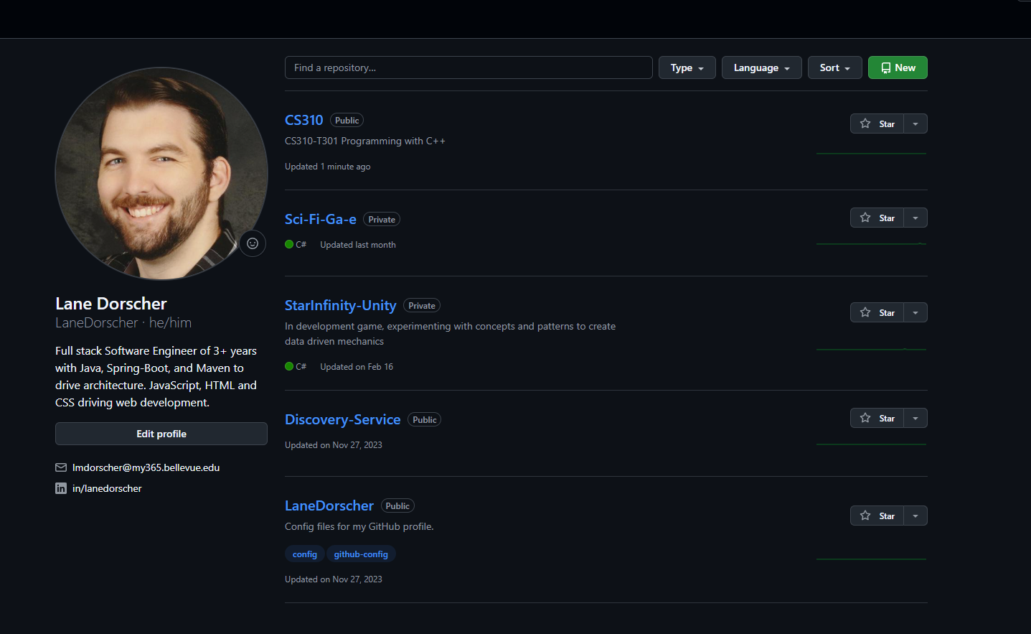

Repository URL: https://github.com/LaneDorscher/CS310.git
README.md URL: https://github.com/LaneDorscher/CS310/blob/main/README.md

